Instructions for running GUI

These instructions should be executed only after the computer is correctly installed and the hardware is properly plugged in.

Arduino setup pictorials (Does not need to be done every time).

Run sensorTracking.ino from C:\engrclinicCoH\IMUSerial\sensorTracking

C:\Users\HMC_clinic\Desktop\2.PNG

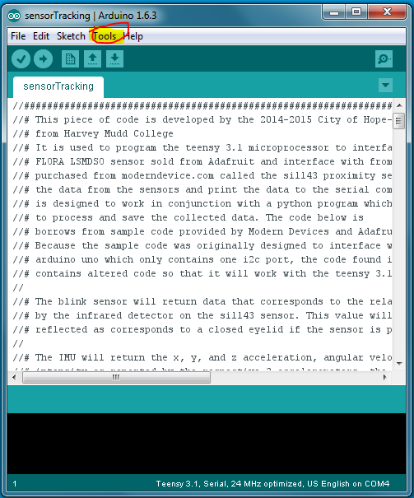

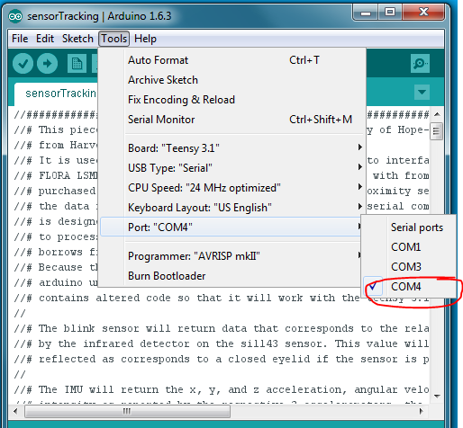



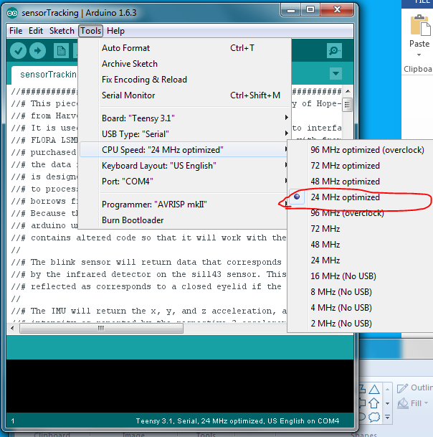

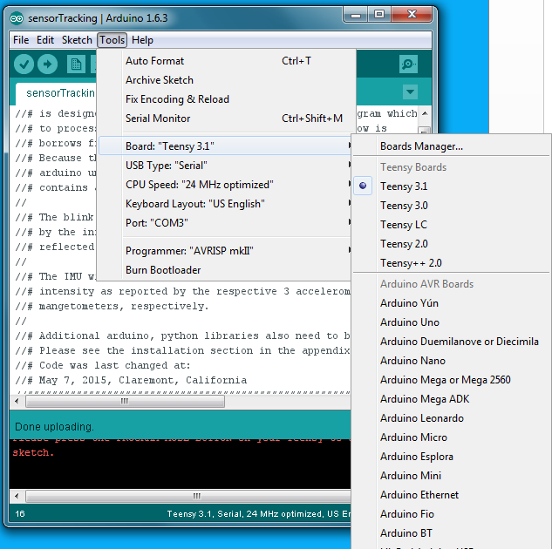

GUI steps (double click)

Run C:\engrclinicCoH\IMUSerial\GUI\_main.py

C:\Users\HMC_clinic\Desktop\1.PNG

The GUI opening looks as follows:

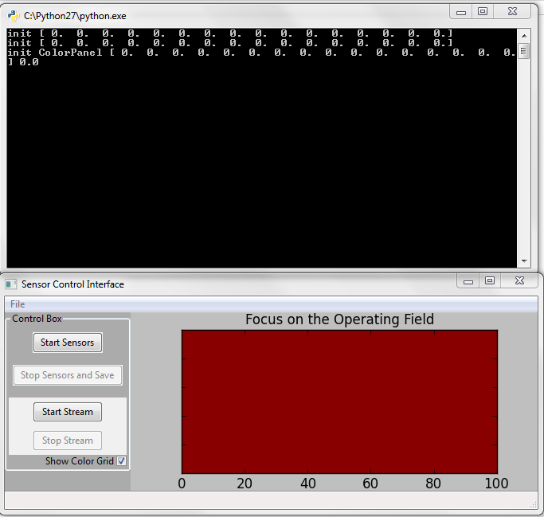

Click “Start sensors”

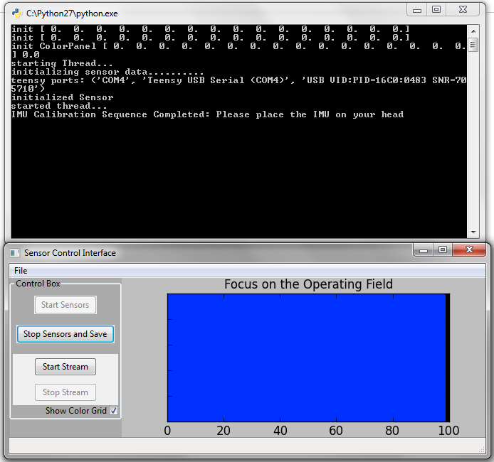

Start the cameras by “start stream”

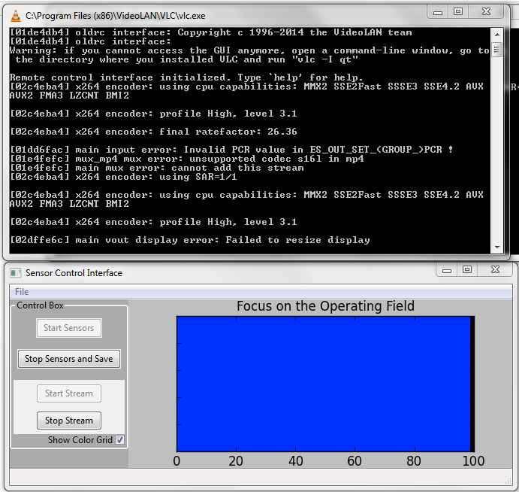

Detected blinks are as shown in the counsel

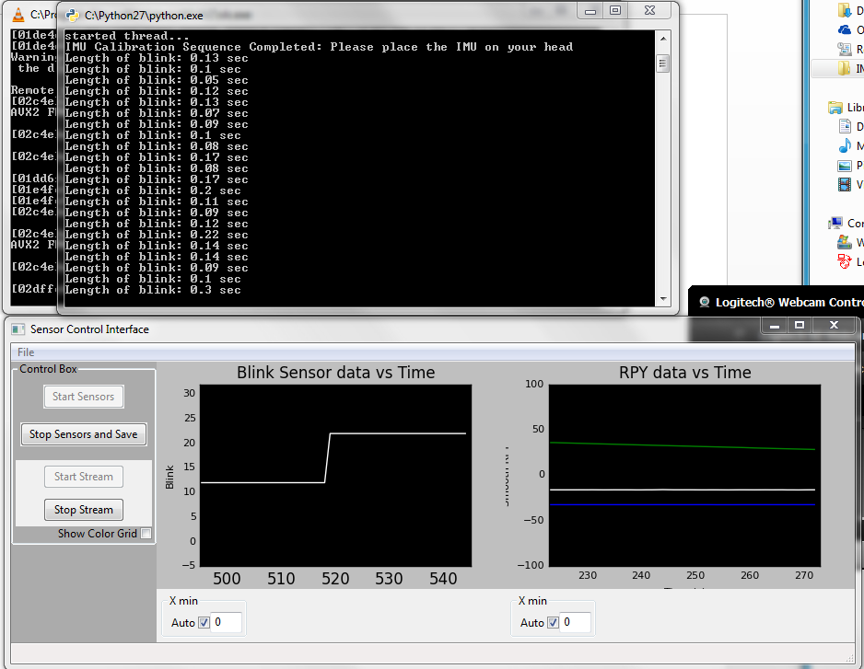

Color grid checkbox switches back to the simple view option

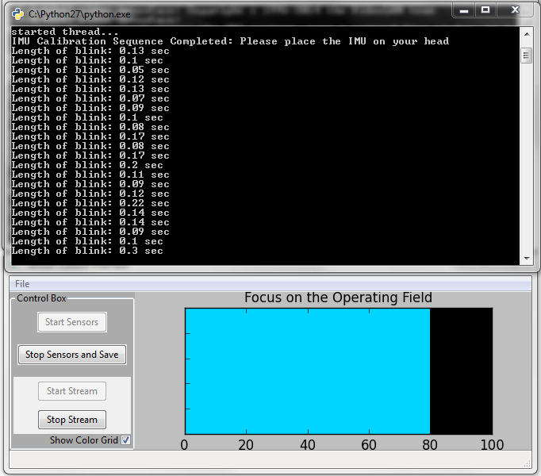

The auto buttons allows the user to view full set of data:

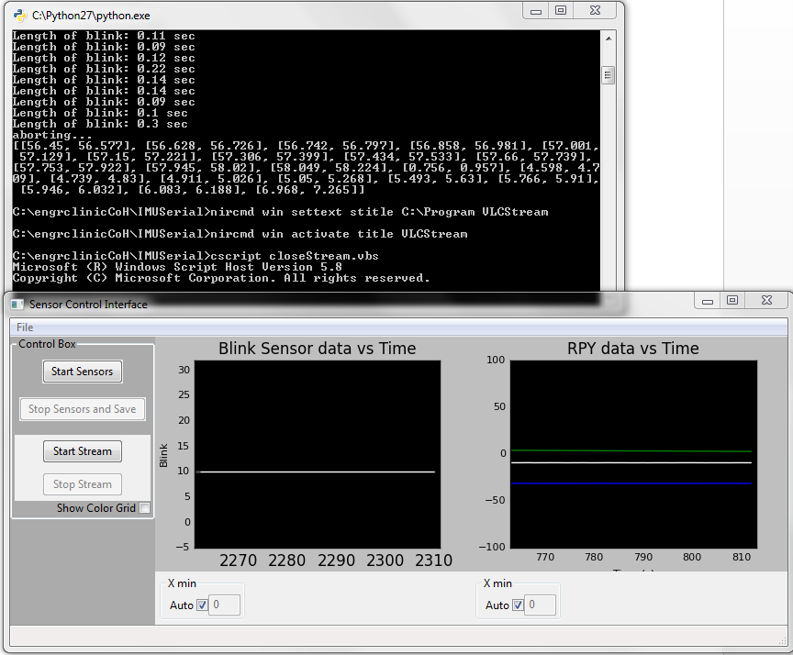

After stopping stream, the sensor values are shown as below:

The camera file is on the desktop

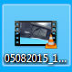

The sensor data saved in the IMUSerial folder.

C:\Users\HMC_clinic\Desktop\9.PNG